Compare Gas Mileage between Japanese’s Toyota Hilux and American Ford F-Series.
Student’s Name:
Institution of Affiliation:
Date
@2018
Table of Contents
Table of Tables iii
Table of figures iii
Introduction 1
Background Information 1
General Objective 2
Specific Objectives 2
Research Questions 2
Hypothesis 2
Null hypothesis (H₀) 2
Alternative Hypothesis (H₁) 2
Rationale of the Study 3
Assumptions 3
Limitation of the study 3
Importance 4
Data Collection 4
Reliability and Validity 5
Data Analysis 5
Summary 6
Data presentation 6
Age of the participants 6
Age of the vehicles 7
Sex of participants 7
Gas/mileage usage of Toyota Hilux and Ford F series. 8
Normality test of population 9
Confidence Interval and Estimation of Gas Mileages 10
Conclusion and Recommendation 11
Acknowledgment 12
References 13
Appendixes 15

Table of Tables
Table 1: Age of the participants 6
Table 2: R output Showing Statistical differences in Gas Millage between Toyota Hilux and Ford F Series 12
Table 3:Raw data 12

Table of figures
Figure 1: Age of the vehicles 7
Figure 2: Sex of participants 8
Figure 3: Gas/mileage usage of Toyota Hilux and Ford F series 9
Figure 4: Data normally distributed 10

Introduction

Background Information
Japan is the third largest automobile market in the world, after China and United States. It exports over 40% of its car and trucks maintaining the most automotive market in the industrial world. In 2008 alone, Japan exported 60% of its truck and cars, with North America and Europe importing most of these vehicles (AAPC, 2018). Over the last two decades, US exports to Japan 183000 trucks and cars, compared to 16.3 million vehicles exported from Japan to the United States. By 2012, America had imported over 96 million vehicles from Japan (Jama, 2018). On the contrary, the American trucks and other mortal vehicles are quite unpopular in Japan.
Typically, American automobile industry such as Ford, General Mortals to Doge has increasingly lost industrial control not only in the world of the automotive market but also in the United States. On the contrary, Toyota, Honda, and Nissan command the highest usability not only in Japan but also in the United States (Carley et al., 2016). Efforts to explain the rising popularity of the Japanese vehicles in the United States are often unclear and unsatisfactory. Some economist, researchers, marketers claims that Japanese have exploited the open market policy while some credit the cost and the size of the Japanese vehicles as a reason why Americans have increasing been fond of Japanese Automobile (Rojon & Saunders, 2012). For others, Japanese automobiles come with more sophisticated technology, hybrid ingenuity and functionality, smart diesel alternatives and limitless customizable features.
With increasing energy and gas crisis over the past few decades, however, one would question whether Americans prefer Japanese care for its longer gas mileage or just for other named features (Qawasmeh, 2017). As such, this project is set to assess whether it’s right or just a myth that Japanese car has longer gas mileage than those of the United States. We hypothesize therefore that Japanese cars have higher gas mileage compared to those of the United States. The project was consequently set with an objective of comparing the performance of automotive gas mileage of a Toyota Automotive with that of a similar automotive from the Ford.

General Objective
The aim of this project studies and compares the performance of automotive gas mileage for Toyota and Automotive from Ford.

Specific Objectives
- To assess the differences in the gas mileage between Toyota Hilux and Ford F-Series over an estimated distance.
- Assess the descriptive characteristic of the sample and participant used

Research Questions
Is there a statistical difference between the gas mileages of Japanese Toyota Hilux with that of Ford F series for an estimated distance?

Hypothesis

Null hypothesis (H₀)
There is no statistical difference between the gas mileages of Japanese Toyota Hilux with that of Ford F series for an estimated distance.

Alternative Hypothesis (H₁)
There is a significant statistical difference between the gas mileages of Japanese Toyota Hilux with that of Ford F series for an estimated distance

Rationale of the Study
Although the project used a simple quantitative researcher, there was no randomization of samples or study subject. A simple no experimental method was used to compare gas mileage in a gallon for Japanese Toyota Hilux with that of Ford F series over one mile. The researcher issued questionnaires to collect data on estimated gas use by either Japanese Toyota Hilux with that of Ford F series in one mile. The data was then tabulated and analyzed to assess whether there were any statistically significant differences in gas mileage in gallon over a distance of one mile for Japanese Toyota Hilux with that of Ford F series. The results from this project would help debunk the popular notion that Japanese vehicles have higher mileage than American made automotive. This information would not only be useful to consumers but will also inform policymakers, marketers and automotive companies on the usefulness of Gas mileage in manufacturing automotive.

Assumptions
The project assumed that both the Japanese Toyota Hilux with that of Ford F series had the same mechanical status, similar millage before the tests, same histories and the drivers were all competent. The project also assumed that all participant questioned derived in the same kind of road and had similar traffic environment.

Limitation of the study
Although this project offers valuable insights on the fuel economy, the project was not performed under controlled conditions. Such controlled conditions would have included car mileage, mechanical condition, the driver, driving speed, Fuel Company used and ultimately the mental and psychological status of the driver.

Importance
Mileage comparison and automotive has been there for decades. With the increasing popularity and the rise of the Japanese Automotive in the United States, over the last couple of years, increased publication discussion and media attention has focused on the comparing mileage consumption between the Japanese automobile and those of the United States. Efforts to explain the increased imported Japanese vehicles in the United States are often unclear and quite unsatisfactory. Quite often marketers, economists and media personnel suggest the cost, efficiency and the size of the Japanese’s automobile as some reason for the increased importation of Japanese vehicles.
According to Senoz (2013), however, American industry like General Mortals and Ford also produce significantly sizeable cars and trucks that most would prefer. While such American automotive companies remain the top in popularity, the rising demand for Japanese car is still a cause for concern. As such, this project set to assess the other common perception; the Japanese automotive have significantly higher automotive millage compared to those of the United States. The project hypothesizes that there is no significant statistical difference in millage distance between the American and Japanese’s Automotive.

Data Collection
The project will use both direct observation and interviews to collect data. The researcher will collect data and information from drivers on the amount of gas in a gallon; a truck uses in a mile. Due to the nature of the project, the researcher adopted a convenient sampling method where he recruited available drivers. The nature of the research did not allow for random selection of the study subject. The project, therefore, selected drivers and truck that were available. Drivers were asked to estimate the amount of gallon per mile that a truck used. The truck selected was either Toyota Hilux or Ford Series. Where drivers were uncooperative, the researcher decided to use direct observation to estimate the number of gallons used per mile. A total of 200 drivers showed interest in participating in the project. However, only data from 158 drivers were used to formulate this report. A copy of collected raw data is shown in appendix 1 below. Before administering the questionnaire, verbal consent was received from each driver. The drivers were then informed that no amount of incentive was to be given after recruitment.

Reliability and Validity
Reliability and validity of data are critical in normalization of data in any research. Reliability is described as the chances or replicating and providing same results. In the data collection process while Validity of data is the ability of the obtained information to meet scientific and scholarly standards. The results from this mini project were reliable since they obtained and collected data in scientific and reliable methods. In the same way, quantification of data and information relied heavily on scientific methods described under data collection procedure and descriptive statistics.

Data Analysis
The study assessed whether there were any statistically significant differences in gas mileage in gallon per every mile between Toyota Hilux and Ford f series. As such, Programming in R was used to perform an Independent T-test, to assess whether there were any significant differences in gas mileage per mile for the two type of truck. The software was also used to and to generate descriptive statistics of mean mode and other tables. The confidence interval was set at 95%. Therefore, a p-value of less than 0.05 would result in rejecting the null hypothesis that there was no difference in gas mileage between the Japanese’s Toyota Hilux and American Ford series over an estimated distance (One mile). On the contrary, if the p-value exceeded 0.05, the researcher then failed to reject the null hypothesis and adopted the alternative hypothesis.

Summary
This project assessed the popular notion that Japanese vehicles have higher gas mileage compared to Automotive from the United States. As such, the project, using drivers, estimated the amount of gallon both Japanese’s Toyota Hilux and American Ford series used in one mile. Using questionnaires, the project selected only drivers who drive either Japanese’s Toyota Hilux or American Ford series to estimated and fill data about gas mileage (Bhatia, 2016). The collected data was then fed on an excel sheet before being imported to and software R for data analysis. The confidence interval was set at 95%. Therefore, a p-value of less than 0.05 would result in rejecting the null hypothesis that there was no difference in gas mileage between the Japanese’s Toyota Hilux and American Ford series over an estimated distance (One mile). On the contrary, if the p-value exceeded 0.05, the researcher then failed to reject the null hypothesis and adopted the alternative hypothesis.

Data presentation

Age of the participants
The mean age of the participants who participated in this project were 40.34 with a median of 44. The youngest participant was 18 years and the eldest was 69 years.
Table 1: Age of the participants
 | mean | Median | Range
Age | 40.34 | 44.00 | 18-69

Age of the vehicles
From the figure1 below, most trucks were I year old, and the number of vehicles reduces as years increase to 6 years. Years 7,8,9 and 13 had only one car each.

Figure 1: Age of the vehicles

Sex of participants
Out of 80 participants, the proportion of male owners of the car were (54.43%) male and (45.57% Female.

Figure 2: Sex of participants

Gas/mileage usage of Toyota Hilux and Ford F series.
An independent t-test was used to compare gas mileage in one mile between Toyota Hilux and Ford F series. There was a significant statistical difference in gas mileage between Toyota Hilux and Ford F series (M, 23.31, SD 0.7138); t (80) = -17.6283, p= 0.0001. Thus, we reject the null hypothesis that; there was no difference in gas mileage between the Japanese’s Toyota Hilux and American Ford series over an estimated distance of one mile (Appendix 1, Figure 1.). Toyota Hilux used significantly more gas per mile compared to Ford F series.

Figure 3: Gas/mileage usage of Toyota Hilux and Ford F series

Normality test of population
Independent t-test compares the means between two unrelated groups with continuous variables. There are various assumptions, however, that these set of the group must meet for an operational independent t-test. These assumptions include the homogeneity of samples, independent observations, and normality of population. In normality, the dependent variable must follow a normal distribution in a population. In this case, the dependent variable was the number of gallon of gas used per mile. The statistical test showed the t data were normally distributed. There was no skewness or kurtosis on the data set collected. Combined with independent observation and homogeneity, these variables, therefore, met the assumption of the independent variable.
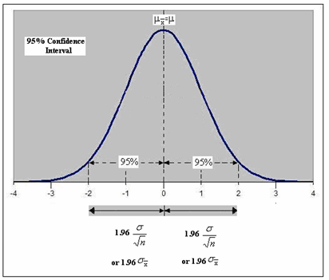
Figure 4: Data normally distributed

Confidence Interval and Estimation of Gas Mileages
In statistical inferences, the confidence interval is an important element. It gives an estimated range of values which is likely to include unknown population parameter. It also set the confidence levels and subsequent p values. For this project, we used a common confidence interval of 95%. Therefore, the probability of observing values outside this area was 0.05. In other words, the probability of rejecting a null hypothesis was therefore set at 0.005.
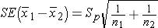
+/-0.1763 (30607-16.012)= 1.96

Conclusion and Recommendation
The aim of this project was studied and compares the performance of automotive gas mileage for Toyota and Automotive from Ford. There has been a popular notion that cars and trucks from JAPAN often have higher mileage compared to those manufactured in the United States. Therefore, we set the hypothesis that there was no difference in gas mileage between the Japanese’s Toyota Hilux and American Ford series over an estimated distance of one mile. Although the independent t-test showed a significant difference in gas mileage between the Japanese’s Toyota Hilux and American Ford series over an estimated distance of one mile, Toyota Hilux, a Japanese Automotive used relatively higher gas per mile compared to Ford F series.
The findings are in agreement with Sallee, West, & Fan (2016) who credit the size and cost of Japanese’s care and trucks as the reason for increased popularity among the Americans. It is possible that apart from there are myriad of reasons why Japanese vehicles are popular in the United States. Such reasons would include the size, cost, technology, customizable features among other reasons. The findings of this project are useful not only to consumers but also very informative and helpful to policymakers, marketers and automotive companies on the usefulness of Gas mileage in manufacturing automotive.
Recommendations
These findings of this project recommend more comparative approach in assessing why Japanese vehicles are increasingly becoming popular in the United States. While this study failed to control the independent variable, doing a more comprehensive study with controlled factors will yield more valuable results. In the same way, another investigative approach should be directed on the size of the vehicles, cost, and technology. The questionnaire for future research should include such variable for a more conclusive finding.

Acknowledgment
I would like to express my senior gratitude to my tutor, family, friends and all those who participated in this project in making it a success. May God bless you.

References
American vs. Japanese – Gas Mileage Comparison. (2018). Daily Fuel Economy Tip. Retrieved 25 March 2018, from https://www.dailyfueleconomytip.com/fuel-efficient-vehicles/american-vs-japanese-gas-mileage-comparison/
Anderson, S. T., Parry, I. W., Sallee, J. M., & Fischer, C. (2011). Automobile fuel economy standards: Impacts, efficiency, and alternatives. Review of Environmental Economics and Policy, 5(1), 89-108.
Bhatia, K. K., & Riddell, W. T. (2016). Identifying and modeling key trade-offs between hydrogen fuel cell and electric vehicles. International Journal of Sustainable Engineering, 9(3), 215-222.
Carley, S., Duncan, D., Esposito, D., Graham, J. D., Siddiki, S., & Zirogiannis, N. (2016). Rethinking Auto Fuel Economy Policy. Indiana University.
Japan Automobile Manufacturer Association (JAMA) (2018). Jama.org. Retrieved 25 March 2018, from http://www.jama.org/wp-content/uploads/2016/11/mvs2016.pdf
Qawasmeh, B. R., Al-Salaymeh, A., Swaity, A., Mosleh, A., & Boshmaf, S. (2017). Investigation of Performance Characteristics of Hybrid Cars. Int. J. of Thermal & Environmental Engineering, 14(1), 59-69.
Rojon, C., & Saunders, M. N. (2012). Formulating a convincing rationale for a research study. Coaching: An International Journal of Theory, Research and Practice, 5(1), 55-61.
Sallee, J. M., West, S. E., & Fan, W. (2016). Do consumers recognize the value of fuel economy? Evidence from used car prices and gasoline price fluctuations. Journal of Public Economics, 135, 61-73.
Senoz, O. (2013). A comparison of American and Asian automakers' vehicles in quality, reliability, and safety. Missouri University of Science and Technology.
The American Automotive Policy Council (AAPC)(2018). How Japan has Maintained The Most Protected and Closed Auto Market In the Industrialized World. Retrieved 25 March 2018, from http://www.americanautocouncil.org/sites/aapc2016/files/Japans%2BProtected%2BAuto%2BMarket.pdf

Appendixes
Appendix 1
Table 2: R output Showing Statistical differences in Gas Millage between Toyota Hilux and Ford F Series
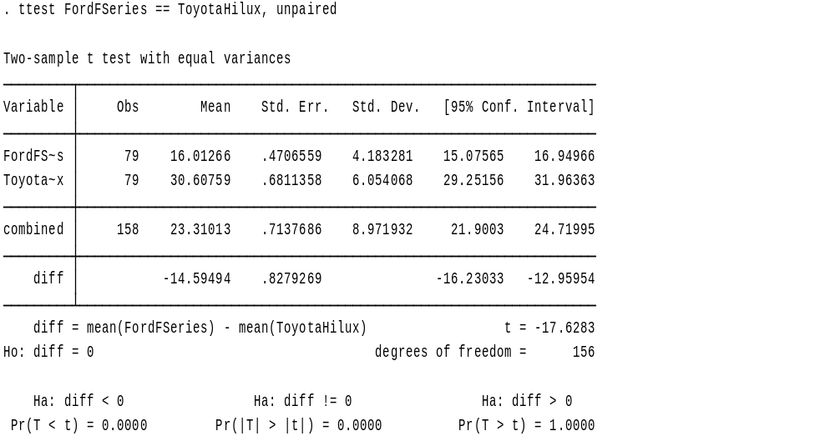

Appendix 2
Table 3: Raw data
Ford F-Series | Toyota Hilux | Sex of the participant | Age | Age of the Vehicle
18 | 24 | male | 25 | 1
15 | 27 | male | 45 | 2
18 | 27 | male | 65 | 1
16 | 25 | male | 44 | 2
17 | 31 | female | 43 | 5
15 | 35 | female | 47 | 4
14 | 24 | female | 54 | 7
14 | 19 | male | 46 | 4
14 | 28 | male | 33 | 3
15 | 33 | female | 34 | 2
15 | 27 | female | 33 | 1
14 | 20 | male | 32 | 1
15 | 22 | female | 31 | 1
14 | 18 | male | 37 | 1
22 | 20 | female | 39 | 13
18 | 31 | female | 45 | 2
21 | 32 | female | 50 | 4
20 | 31 | male | 53 | 3
10 | 32 | male | 51 | 4
23 | 32 | male | 49 | 3
14 | 34 | female | 46 | 4
14 | 26 | male | 47 | 2
14 | 30 | female | 45 | 1
12 | 22 | female | 45 | 1
13 | 22 | female | 46 | 4
13 | 33 | male | 47 | 2
18 | 39 | male | 18 | 6
22 | 36 | male | 19 | 3
19 | 28 | male | 21 | 5
18 | 27 | male | 22 | 4
23 | 21 | female | 24 | 3
26 | 24 | male | 25 | 2
25 | 30 | female | 26 | 1
20 | 34 | male | 45 | 1
21 | 32 | female | 45 | 1
13 | 38 | male | 47 | 6
14 | 37 | female | 43 | 4
15 | 30 | male | 38 | 3
14 | 31 | female | 38 | 3
18 | 38 | female | 39 | 3
11 | 32 | female | 44 | 3
13 | 47 | male | 34 | 3
12 | 41 | male | 56 | 2
13 | 45 | male | 67 | 2
15 | 34 | male | 65 | 2
13 | 33 | male | 45 | 1
13 | 24 | female | 54 | 1
14 | 32 | female | 53 | 4
14 | 32 | female | 62 | 3
22 | 39 | male | 51 | 2
28 | 35 | male | 30 | 1
13 | 32 | male | 30 | 3
14 | 37 | male | 31 | 2
13 | 38 | male | 25 | 2
14 | 34 | female | 32 | 2
15 | 34 | male | 34 | 2
12 | 32 | female | 50 | 1
13 | 33 | male | 45 | 1
13 | 32 | female | 43 | 2
18 | 34 | male | 24 | 3
16 | 36 | female | 26 | 2
11 | 38 | male | 21 | 3
12 | 32 | female | 20 | 1
13 | 31 | male | 37 | 1
18 | 36 | female | 30 | 1
10 | 24 | male | 45 | 3
11 | 26 | female | 67 | 3
9 | 29 | male | 50 | 5
17 | 37 | female | 44 | 4
19 | 28 | male | 45 | 4
18 | 19 | female | 47 | 3
14 | 25 | female | 34 | 2
13 | 24 | male | 21 | 2
12 | 37 | female | 21 | 1
28 | 24 | female | 23 | 9
25 | 24 | female | 20 | 8
19 | 33 | male | 69 | 6
16 | 33 | male | 65 | 5
17 | 32 | male | 45 | 5

